Market Research

# Introduction

This document aims to detail the types of applications that are already available to patients and carers. The document will look at a subset of applications in further detail and comment on the following:

1. Compatibility
2. Design
3. Functionality
4. Ease of Use
5. Speed
6. Reliability

Security is another aspect that will we also be considering with great care and attention when producing our application however, this is something that we are not going to directly look at when carrying out market research. We will be using best practices that conform to UK data protection and privacy laws as a baseline and feel it would be inappropriate to look at the security of other applications in order to determine a baseline for our application. Therefore, this will not be discussed in this document.

# Healthcare Applications

There are a whole range of mobile applications and websites that are available within the pharmaceutical and healthcare industries. Generally, the web applications are more sophisticated and advanced whereas the mobile applications are somewhat less sophisticated and developed within this market.

There are some very well-known web applications within the UK such as, NHS Direct website and mobile application. However, there are also many mobile applications that are less well known; some of these are produced by government organisations, some by healthcare companies such are the pharmaceutical giant GlaxoSmithKline and others are produced by charities.

The majority of these applications are geared towards patients or the general public and contain information about certain conditions, the symptoms that a sufferer may experience and some advice about what to do if you believe you may have the condition/illness.

In recent years there have been so many of these applications developed that both Apple and Google have entire sections of the app stores that are dedicated to apps categorised under ‘Medical’. A report in 2013 showed that Apple’s App Store has approximately 20,000 medical apps whereas Google’s Android Play store lists 8,000 (Aungst, 2013).

There are also applications that are used internally within the NHS to support nurses and carers in treating patients as well as recording health information about them such as heart rate, blood pressure and medication.

# SystmOne

SystmOne is a clinical software that is produced by a company names TPP, it was first released in 1999 and is adopted by the NHS as a part of the National Programme for IT and their vision for a ‘one patient, one record’ model of healthcare (TPP-UK, 2011).

SystmOne is an enterprise product that is made up of several modules; these are able to be used to together or individually as a standalone solution. The module that is most similar to the vision of JustHealth is the SystmOne ‘Community’ module. This is used by NHS district nursing teams in 107 different Primary Care Trusts (TPP-UK, 2011), including South West Essex Community Services (SWECS) who use the software when visiting patients at home to update the software.

Before the introduction of the SystmOne Community module the carers/nurses that would visit the patients home would have to duplicate there work by recording by hand information about the patient and then when they arrived back at the hospital/clinic where they were based they would have to copy this information electronically into the system. However, SystmOne has enabled nurses to be able to do this whilst on the move as in particular SWEC have given all of their nurses an HP Toughbook to ensure that they are able to do this on the move which means that each nurse is able to see more patients and/or spend more time with the patients that they visit.

## Functionality

SystmOne: Community has many features and functionalities, some of these are aimed at the carers/nurses and others are directed towards management and administrators. Management functionality is much to do with reporting on workload of the Primary Care Trust as a whole, individual nursing units, or individual members of staff. It is also capable of running reports on waiting times and referral reasons. Due to the scope, time and resources allocated to the JustHealth project it is unlikely that this functionality would be built into the application.

Furthermore, the administrators are also given full access to SystmOne so that they are able to schedule appointments and assign patients to other nurses/carers. Administrators are given full access to the system so they would be able to update patient records. This seems to be somewhat unnecessary and JustHealth believe that administrators should only need access to patient profiles; to update address/doctor/next of kin and so on and to add appointments however, they should not need access to patient information such as blood pressure, heart rate and medication and if this is required it should be read-only access.

Nurses are able to update SystmOne with a whole range of different information, including:

* Pulse
* Blood Pressure
* Height

SystmOne will calculate BMI

* Weight
* Alcohol Intake per week
* Substance abuse
* Cigarettes smoked per week
* Medication
  + Name (lookup in database of drugs)
  + Dose
  + Frequency
  + Reason (optional)
  + Date Started
  + Date End
* Booking appointments
  + Update when on route
  + Update when arrived
* Group patients and nurses
  + I.e. Cardiac, Oncology, Paediatric etc.

## Ease of Use

SystmOne: Community is not as easy to use or as effective as it could be. Initially, the learning curve is very steep and can often confuse users. SWECS employs around 3 IT Systm One trained staff to show users (nurses/admins/management) how to use the system effectively and help them with any issues that they may have. The system has small buttons that often appear to be hidden away and this makes the use of the system difficult especially as the users are often not technically minded. Further to this, the colour scheme of the system is bland; it is mainly grey which also makes the system difficult to use.

Moreover, the system opens all of the text input boxes up in separate windows, which makes the application fairly slow and arduous. Oncology and Cardiac nurses/carers typically spend around 40mins with a patient so the time that it takes to fill out this information isn’t quite so important although, this time should be spent with the patient. However, general nurses/carers will spend less that 10minutes with a patient and the majority of this time is spent taking the patients pulse, blood pressure and checking their medication. This leaves around 30seconds – 1minute to enter in all of the details; it would be much easier if these were all on a single page.

## Performance

The performance of SystmOne is good and it has to be in order for nurses/carers to be able to make all of the visits that they are required to make and also ensure that they update records efficiently and accurately. Although, performance is crucial the auditing of the records that are committed is also very high. This is to ensure that who changed what and when is all recorded and available to view if needed. This is essential to ensure that if needed, users can be held accountable if records are inaccurate or corrupt.

## Patient Interaction

SystmOne provides no patient interaction capability and patients are unable to view the information held about them in SystmOne from the nurse/carer that is visiting them. This is to ensure confidentiality of other patients too however, if a patient does request the information that is held within SystmOne about them then this can be printed and given to them in paper format, not electronically. If the system provided patient login and they were able to see information solely about themselves this would save the NHS money and also save staff the time that it takes to speak to the patient, find their information, print it and deliver it to them.

## Recommendations

1. Application Speed is crucial, if this is lacking it would be impossible for the carers/nurses to use it on the move.
2. Both a web and mobile interface would be better than SystmOne as this is currently only available as a windows OS install, which consequently restricts the type of endpoint that can be used to access the system.
3. It would be good for changes to only need to be held locally and committed when a good internet connection is available.
4. 2-Factor Authentication is 100% necessary.
5. Simple, easy to use interface, large buttons with no/minimal scrolling would be best.
6. Manage access effectively, work on a need access, give access basis.

*All of the above was taken from a telephone interview with Dean Markwick, a former Mobile working Assistant for NHS,South West Essex Community Services. The full interview can be seen in appendix one.*

# Analysis of consumer based applications

This section looks at some of the consumer applications that are produced by healthcare and pharmaceutical companies and added to the Android and Apple app stores. Below, the following applications will be reviewed and compared:

1. **Piri Pollen Application, GlaxoSmithKline**

This application is designed for hay fever sufferers; it gives a pollen forecast and allows the user to set medication reminders. Specifically, targeted at consumers of Piriteze, the application allows you to find your nearest store to buy the product or order online. This application was taken off of the app store in June 2014 due to technical difficulties with updating the pollen count readings based on postcode.

*Note: This app has now been taken off of the ‘App Store’ as can be seen in an email to the application owner in Appendix 2, however as an employee of GlaxoSmithKline, I (Stephen) was given access to the application so that I could see how it worked.*

1. **MediSafe Meds & Pills Reminder, MediSafe Project**

MediSafe is a medication reminder app, it allows you to add the medication that you are due to take and will remind you when you should be taking the pills. If you don’t mark the action as complete the app will alert your selected MediSafe buddy. Also, the app facilitates a reporting feature showing if and when medication has been taken and when prescriptions need to be renewed.

## Compatibility

The MediSafe application is available on android as well as iOS, although it does not have a front end web interface; this is something that we thought would be particularly beneficial as a website would not restrict the user based on what device they own, as this will be accessible from any device whether it be a smartphone, tablet or PC. The Piri Pollen application is only available on iOS and although it does have a website that is able to tell you the pollen count for your local area as well as order the Piriteze drug, it does not facilitate the use of the medication reminder functionality.

Furthermore, the MediSafe application is adapted for larger screens, such as the use of tablets as well as smart phones which tend to have smaller screens. This is very useful and again makes the application accessible to people that have either android smartphones or tablets. On the other hand, the Piri Pollen app is only available on the iPhone and not on the iPad which limits the user base of the application. Although, for the JustHealth project both smartphone and tablet compatibility are crucial, smartphone compatibility should be prioritised higher than the tablet as these device have a larger user base.

The MediSafe application is compatible with android versions 2.3 and higher. This is important to ensure that users are not able to access the application if they are not on the latest version of android. We should also consider the security requirements of the application and ensure that versions that have potentially catastrophic security vulnerabilities are either mitigated by the coding of the application and/or not supported by the application.

## Design

Design is extremely important within any mobile application to ensure that they are easy to use and are also appealing so that users are encouraged to firstly download the application and subsequently use it. Often design heavily influences the ease of use of an application and if to complex can impact the performance too. This will be something that we will be required to manage throughout the development life cycle of our application to ensure that we strike the correct balance.

### Interface Design

**Piri Pollen Application**

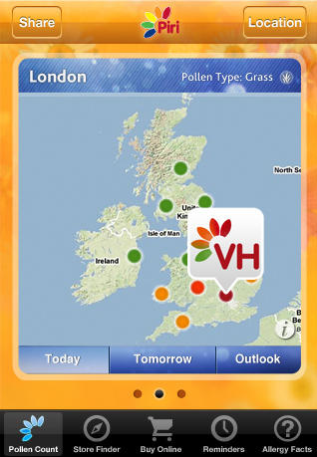

*The application logo is always displayed at the top of the application which helps to build the brand and gives a consistent feel and identity to the application.*

*The bar at the bottom is viewable from all windows which again enforces a consistent feel to the application. This also makes the application easy to navigate.*

*The applications colour schemes make it look somewhat outdated and unappealing to the eye.*

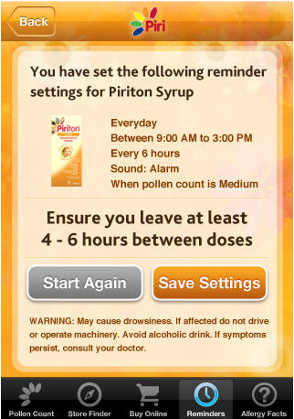

*This is a duplicate button of the ‘start again’ button. This may be confusing to a user.*

*Customary, automated inputs from the application. This is a nice feature although, may not be applicable for people with chronic health conditions.*

*The buttons are clear and the colour contrast between the buttons makes it clear which is to proceed and which is to go back a step.*

*Checks that the user is happy with the decision that they have made. This adds a step in to the process that some users may find frustrating and time consuming although, this should be done to check that the reminder is as expected/needed otherwise it may have serious consequences if the patient is to miss a dose.*

*This warning is displayed to ensure that the user is aware of the possible side effects. This demonstrates a corporate social responsibility which users may find reassuring and build their trust and confidence in the application.*

Ultimately, the Piri Pollen application has both good and bad features in its user interface design. IU feel like the application looks quite dated and this is largely down to the colour scheme. I can see that this colour scheme has been adopted because this is the same colour scheme as the Piriteze medication box although, in the application I don’t feel that this works. As discussed previously, the website for the Piri Pollen application doesn’t have the same functionality as the mobile application and it also has a very different look and feel. Also, the branding is not consistent; the website shows the GSK logo as well as the Piriteze logo. This gives the application an unprofessional feel and that is something that the JustHealth application should aim to avoid. Having said this, the application is reasonably easy to navigate with large buttons that are suitable for the touchscreen interface.

## Functionality

The Piri Pollen app is specifically tailored for hay fever sufferers and therefore some of the functionality that this provides is not relevant to the proposed JustHealth application. Having said this, some functionality could be utilised in a different way to achieve similar requirements, only those functionalities of the Piri Pollen application that may be of use will be mentioned below:

1. Medication Reminders – this feature is well implemented on the application, it also tells a user based on logic about the pollen count when they should take a tablet. The feature is clearly laid out and easy to use.
2. Allergy Facts – This information is all integrated into the application which is very useful and provides a holistic feel to the application as everything you need to know and use is all available within the application.
3. Store Finder – This is another feature that would be great in order to be able to find out where to find the nearest pharmacist or in this case another retail outlet that sells the medication.

## Ease of Use

The Piri Pollen application is easy to use; there is no need to go anywhere else other than the application to get everything that you need with regards to a hay fever allergy. The buttons are fairly large and there purpose is clear. If you make a mistake setting the reminder this can be easily changed too which adds to the great user experience, not only can they be changed once you have set the reminder but before this there is also a confirmation screen to check that you are happy with the reminder conditions that you have specified.

## Speed

The Piri Pollen application is great in terms of speed once it has booted, however the opening of the application from the phone home screen is slow and could be frustrating to a user. It would be beneficial if there was a loading bar at boot up to at least reassure the user that the application is booting and will take ‘x’ amount of time to do so.

## Reliability

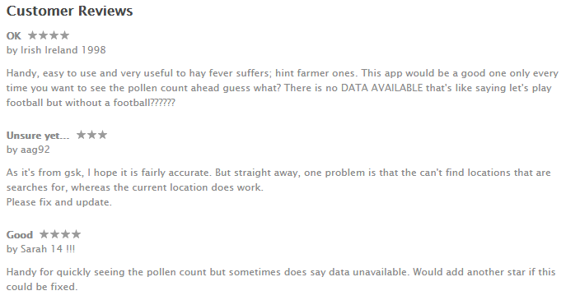The reliability of the application was affected by the failure of an automatic update feature of the daily pollen count and this was reflected in customer reviews on the ‘App Store’ as can be seen in the screenshot below.

Also, as can be seen in the above screenshots one of the reviews stated that the current location feature that is built into the application did not work although this wasn’t something that I was able to replicate when testing the application.

# Appendix One

An interview carried out over the phone with Dean Markwick, a former employee of the NHS, South West Essex Community Services

For the purpose of writing down this interview questions asked by Stephen Tate will be in red and answers by Dean Markwick will be in black.

Could you please briefly outline your role at the NHS?

Yes, I was a mobile working assistant working within the South West Essex Community Services. I was using a piece of enterprise software called SystmOne and was a part of a rollout where community and district nurses/carers were being given HP Toughbook’s to be able to use this whilst visiting patients in their homes.

Could you please outline what SystmOne is?

SystmOne is a enterprise application that has been employed by several NHS trusts throughout the UK and essentially it stores records, schedules nurses, stores patient records, manages the ordering of medication, calculates BMI and alcohol intake – essentially it does nearly everything that a hospital/GP/nurse would need to do.

Is SystmOne accessible to patients?

No, SystmOne is solely for the use of NHS staff. Patients are able to request the information stored about them however, this would have to be a paper copy.

What security is employed within SystmOne?

There will be multiple layers of Security protecting the backend servers both technical security as well as physical security of backend infrastructure. In terms of what security this is, I am not too sure. However, I know that 2-Factor Authentication is used and the system comes up to **[ACTION]** NHS Data Protection Requirements, I can try to send these to you.

What does SystmOne do particularly well?

* Scheduling – ensuring nurses are aware where they have to be
* Allowing nurses to input details about a patient into the system in real time
* If a nurse is on holiday the patients assigned to that nurse will be distributed to other nurses in their pool (Note: Nurses are arranged by category e.g. cardiac, oncology, general)

How easy can the System be learnt by a new nurse for instance?

SystmOne isn’t easy to use at all. Nurses find the initial learning curve to be very steep and they also find it frustrating that the